**Install Anaconda and setup project**

1. Install Anaconda. Please follow this link:

<https://www.anaconda.com/distribution/>

The install process is straight forward. You just proceed by clicking next on everything pretty much.

1. Open Anaconda. This window should pop up.

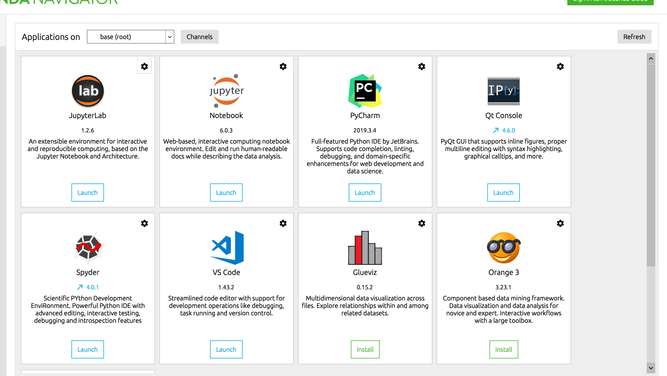

1. Click on JupyterLab as shown in red circle. This window should show up. There are two main “boxes”: the left one and the right one. 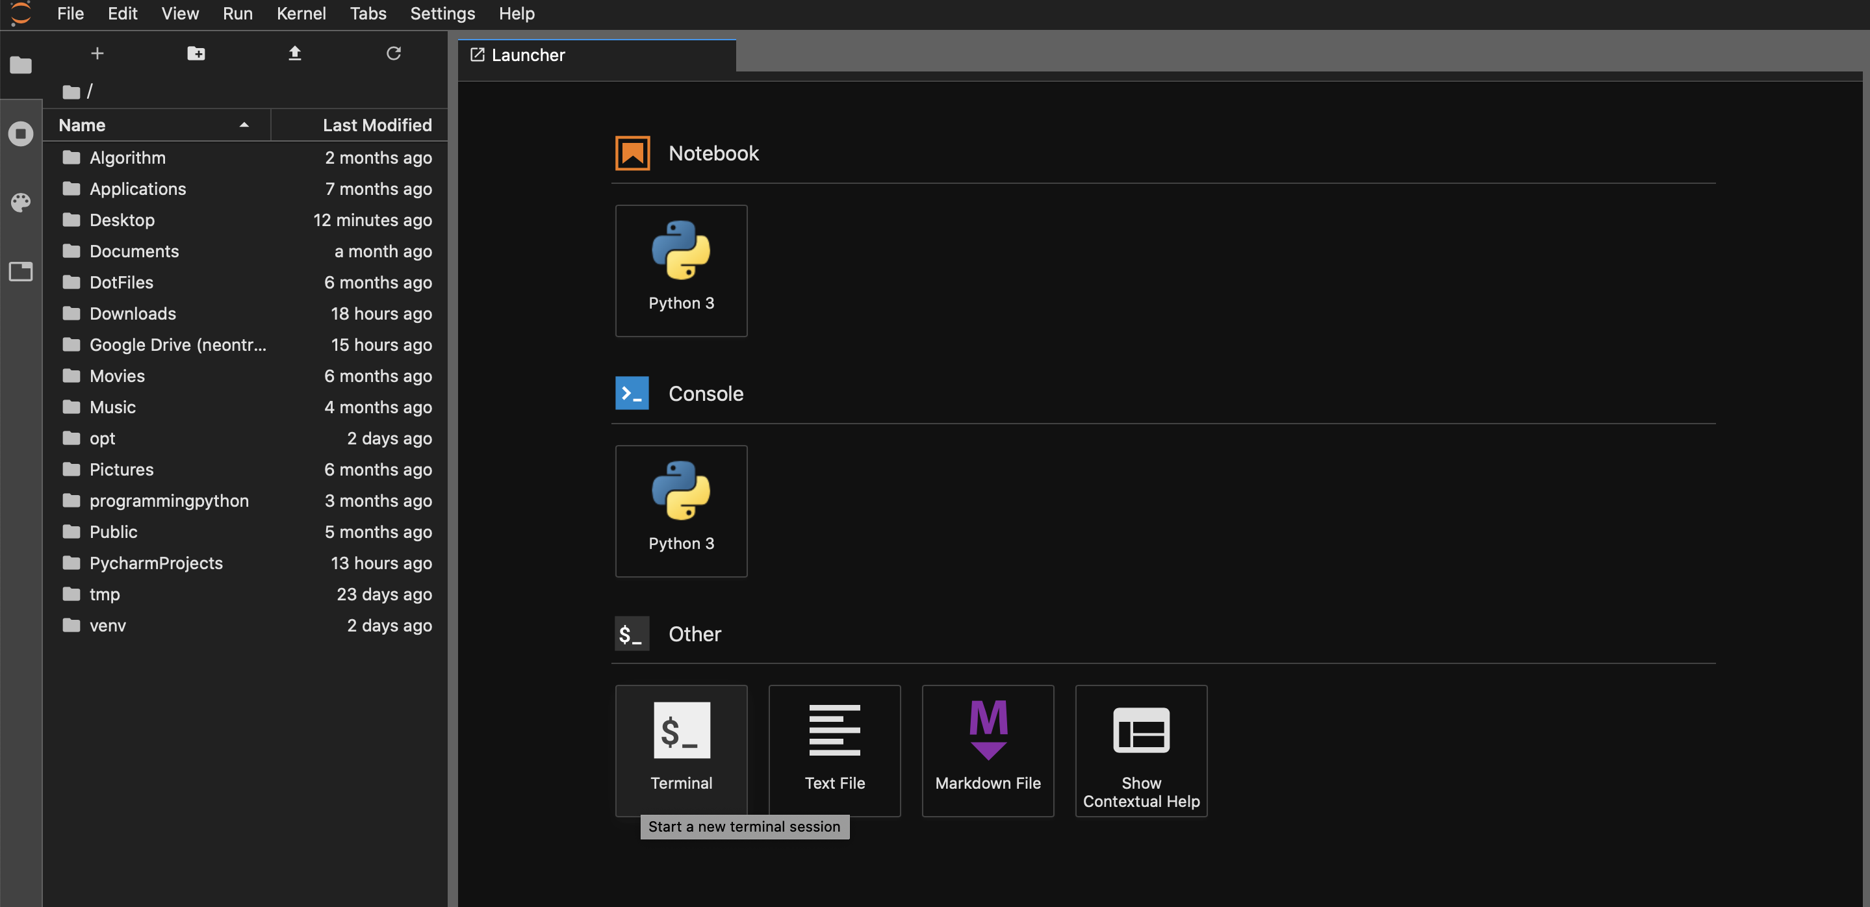

The left side box shows the folders that Anaconda currently sees (so it can read codes and excel files and everything).

The right box is the current working window session. This could be an Anaconda file or a Python file. You can modify the code directly from here.

For your end, you will only have to modify Anaconda file (which is currently shown on the right side here). The Python file is the low-level programming and you don’t have to worry about it.

1. Unzip the project file, (JackieProject) and place it under:

C:\Users\(your-computer-name)

For instance, if your computer name is Jackie, it should be:

C:\Users\Jackie\

Or if you want to create a separate folder for this project, you can do, for instance, C:\Users\Jackie\DrillingProject

I recommend the first way and will proceed assuming you follow that.

1. Now, on the left side of Jupyterlab (as shown above), you should see the folder JackieProject. Double-click on that folder.

At the end of these steps, you should see this:

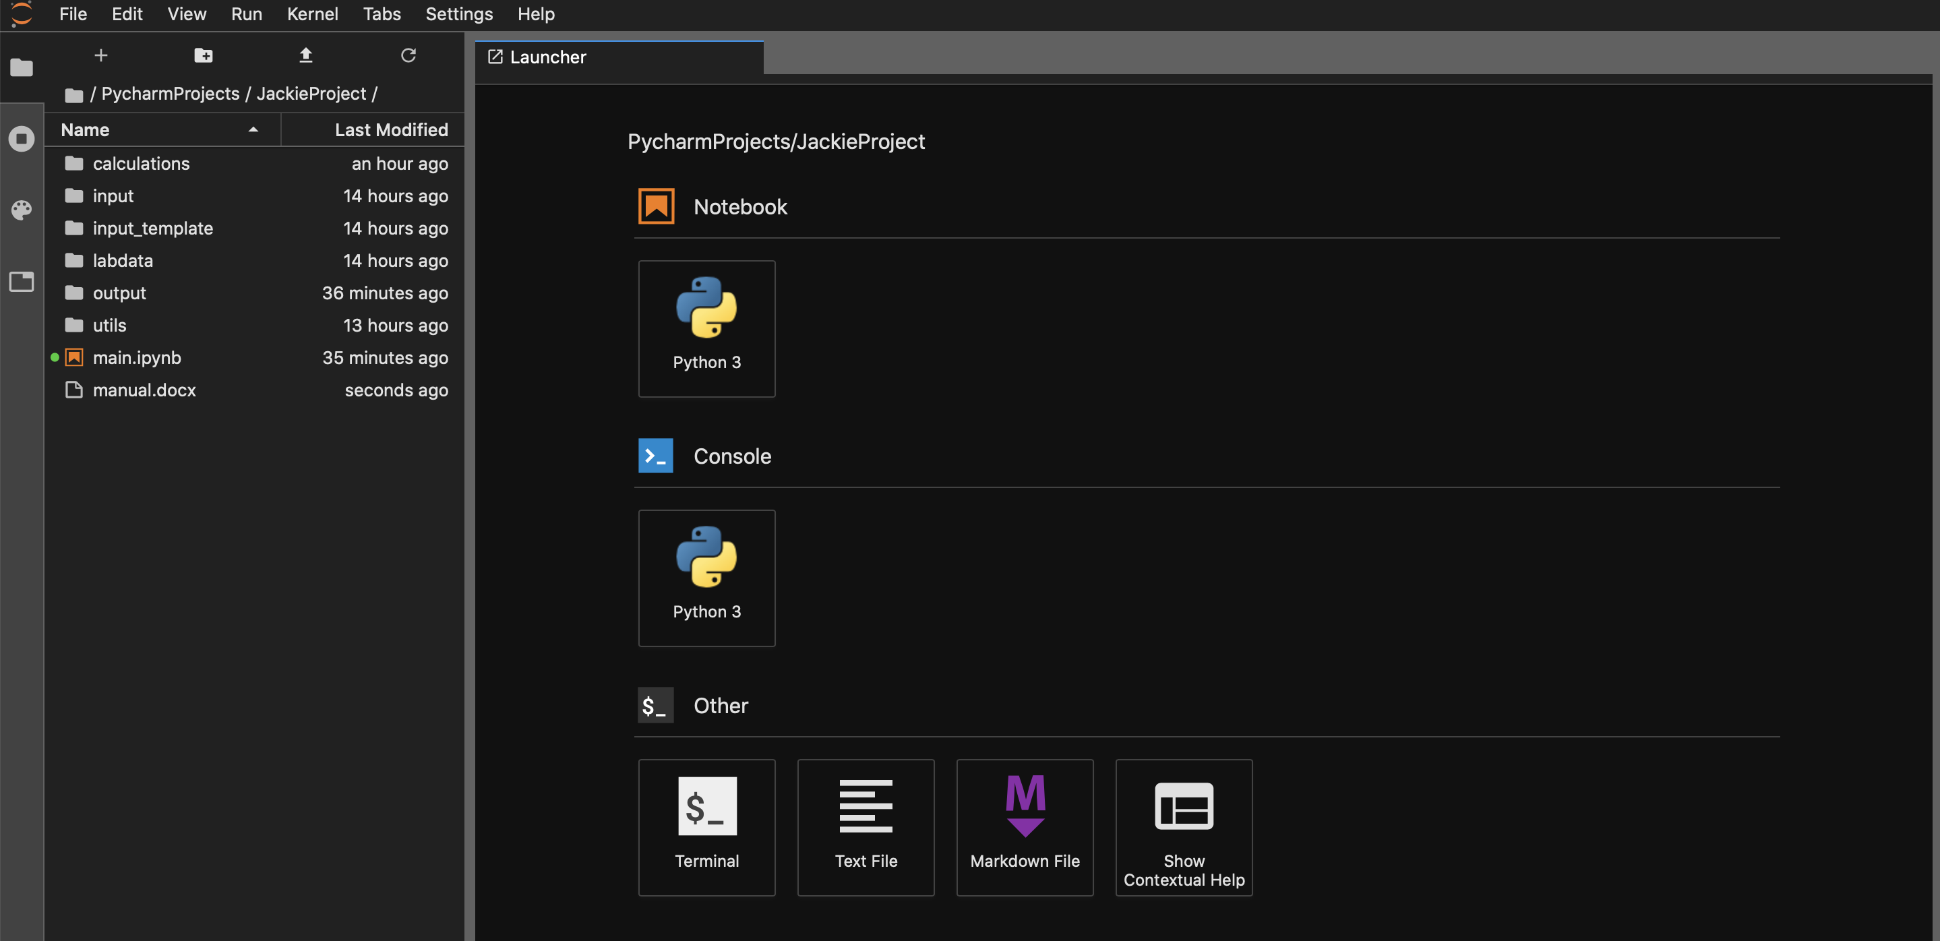

1. Clic on main.ipynb, now it should look like this:

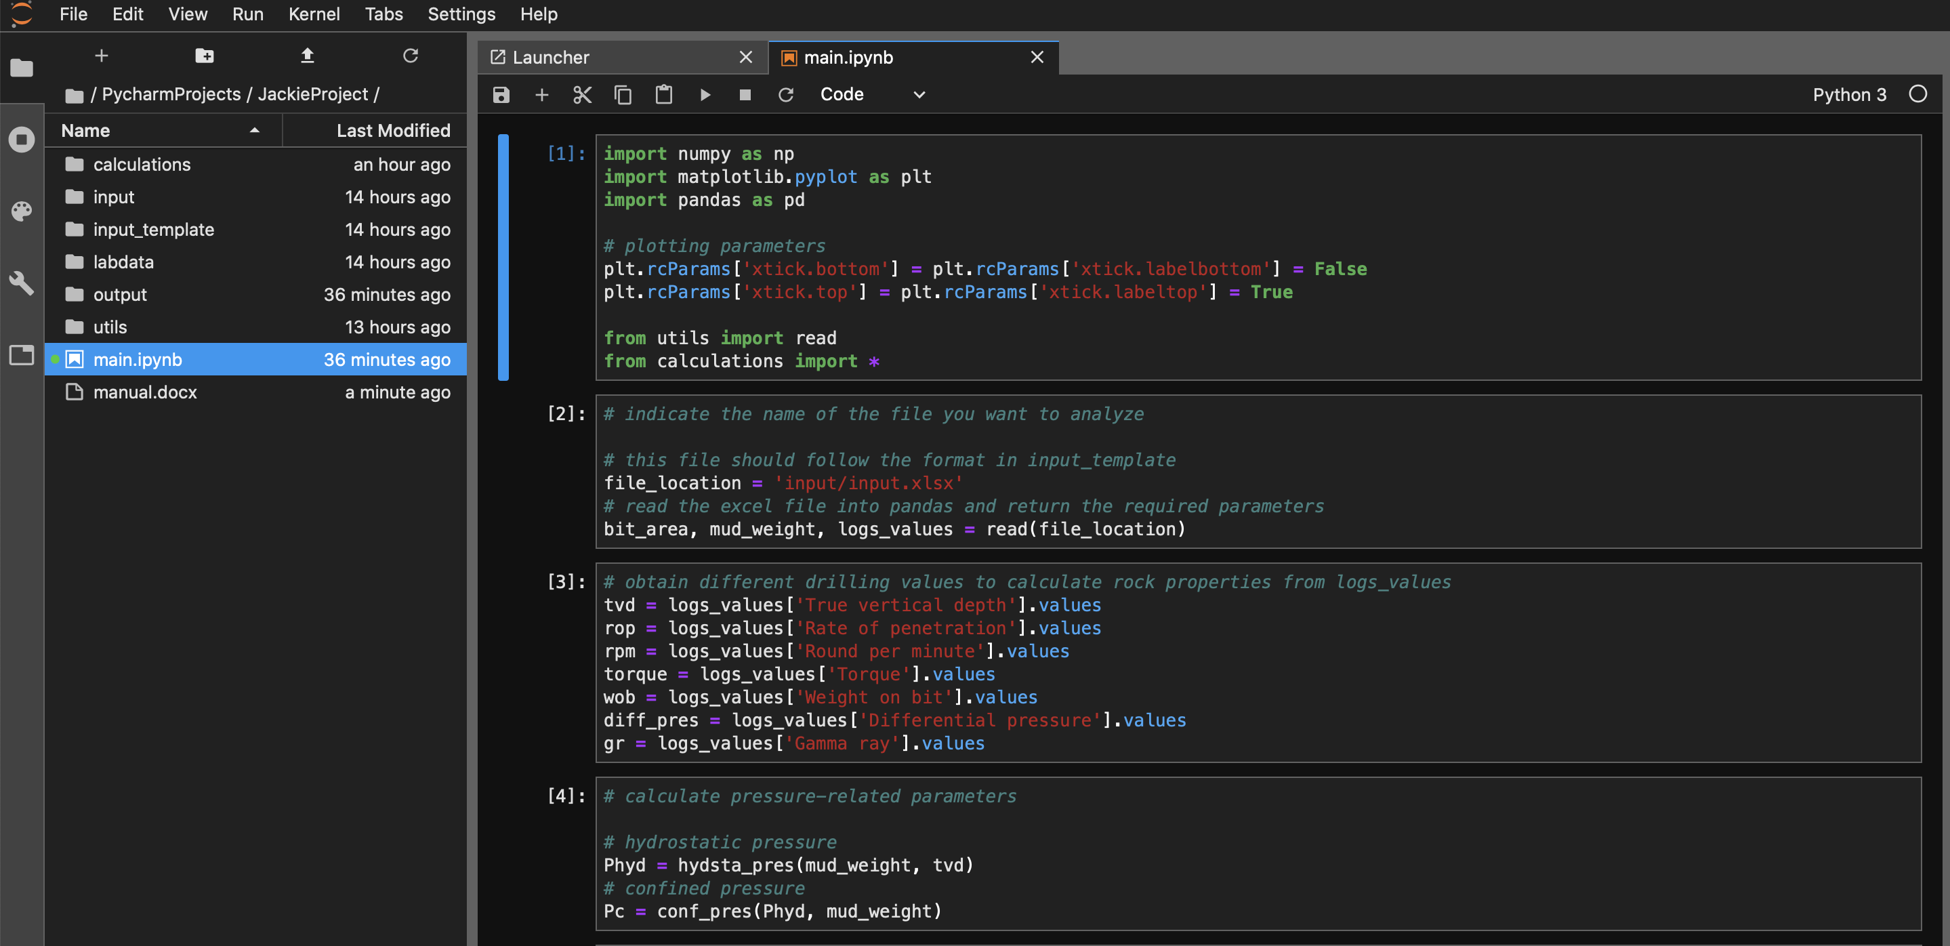

**Input data**

Now let’s look at the folder you just unzipped to input data.

Pay attention to folder input and input_template.

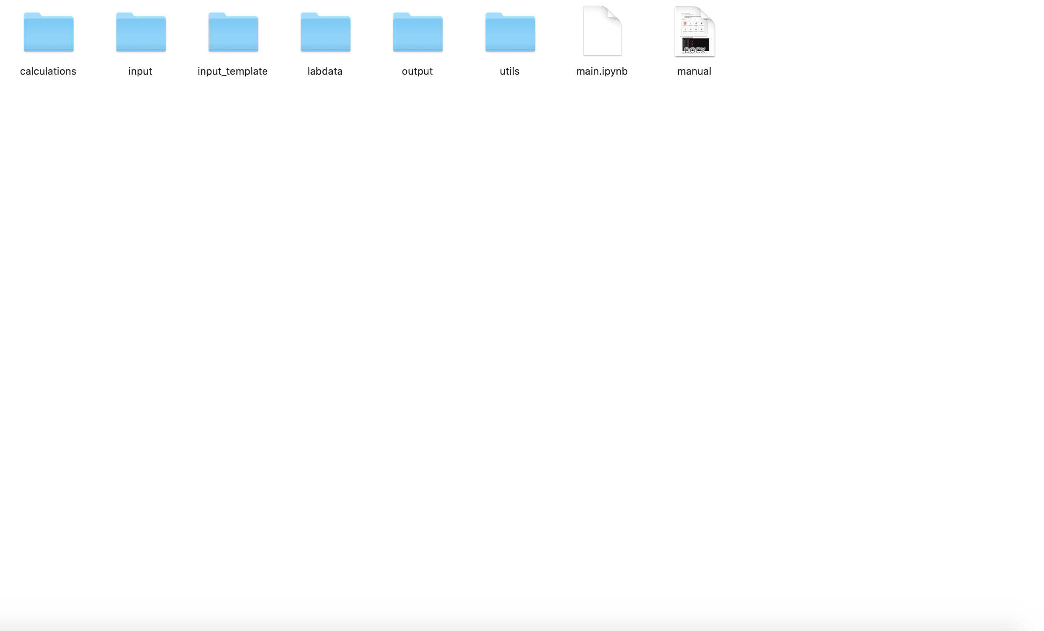

1. Click on input_template. And open input_template excel file.

You should see an excel file with three tabs: drilling bit, drilling mud, logs

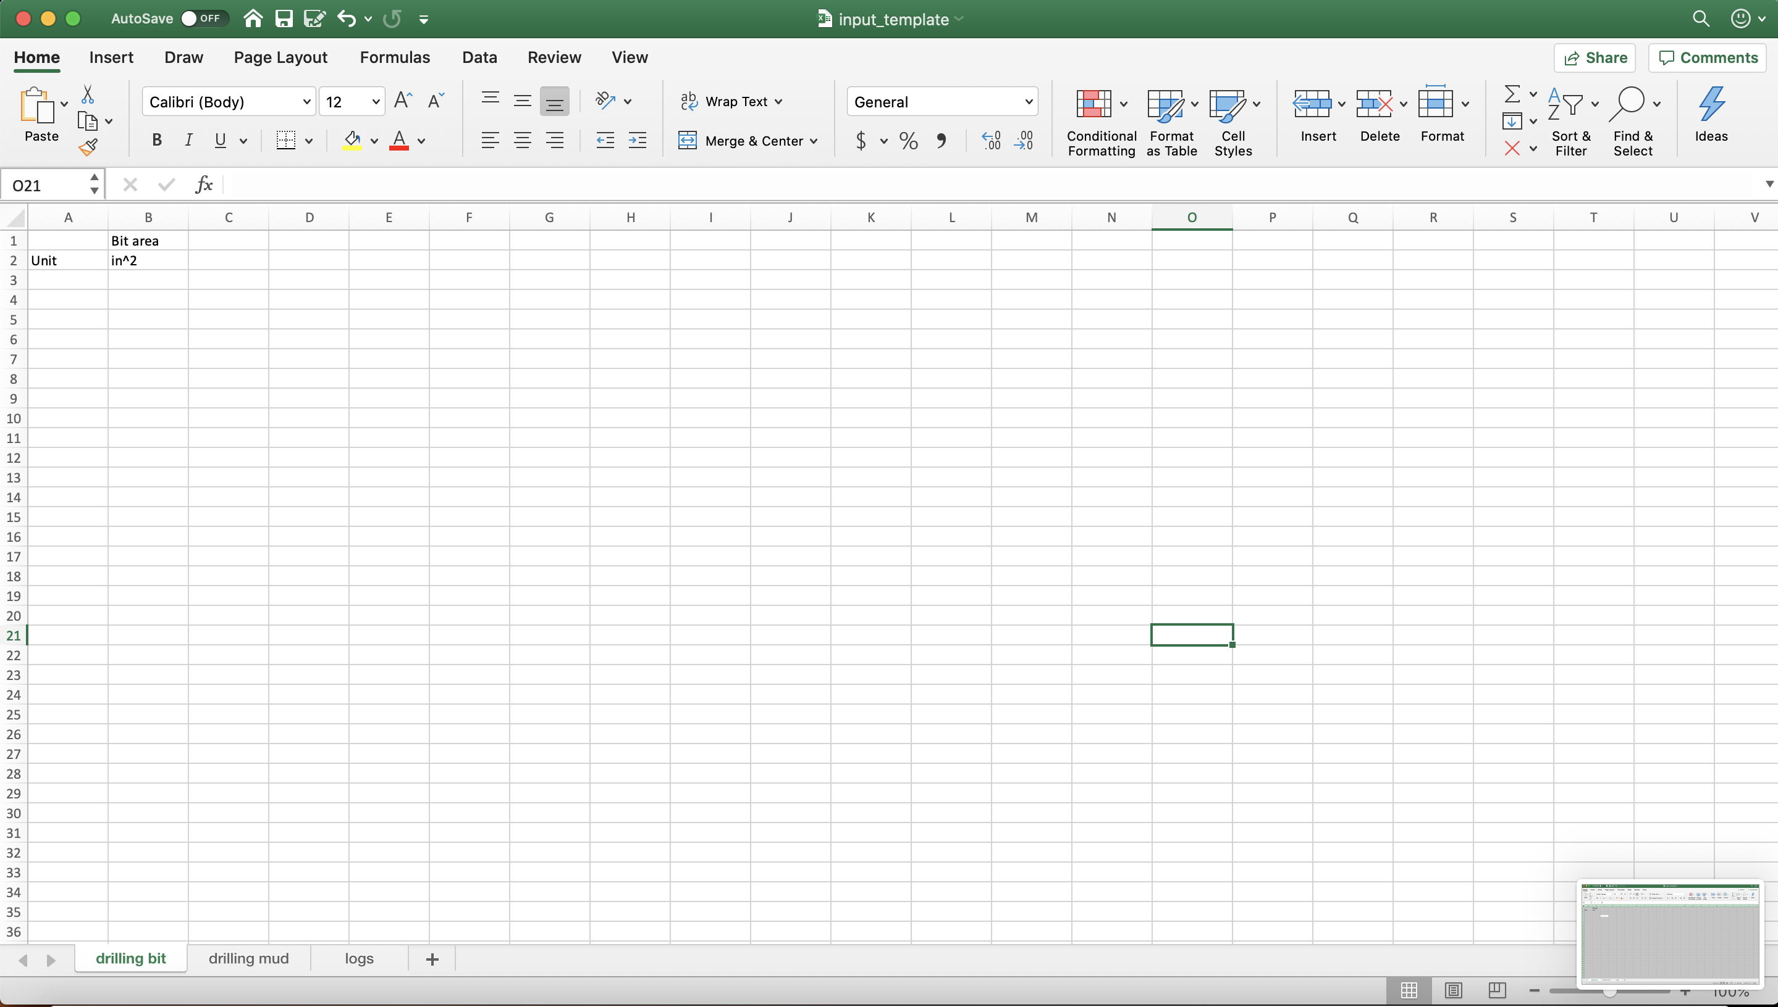

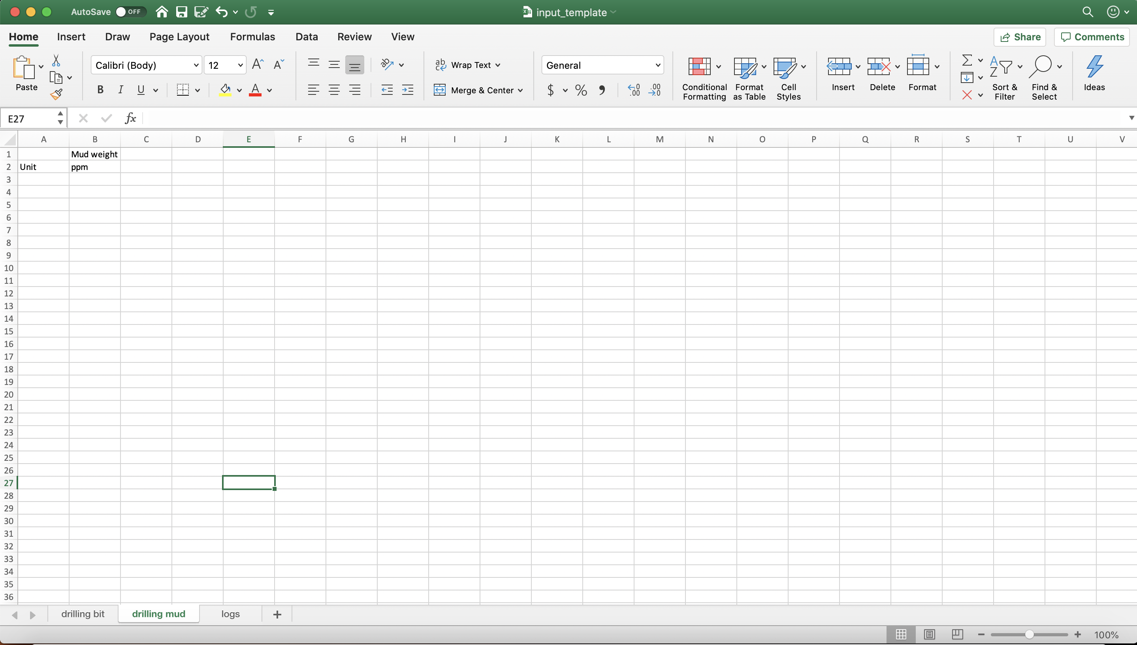

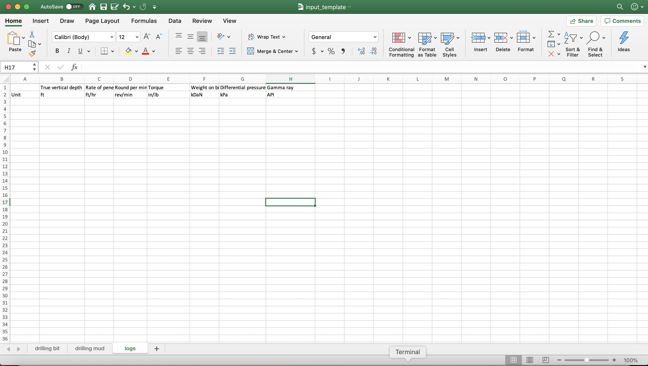

This file contains the excel template for you to use in the future. The Anaconda file will work as long as you follow this excel format. If you have other data that you want to run an analysis, please follow this template to input the values.

For instance, after you collect the data you have, open the input_template excel file, and input them as follow:

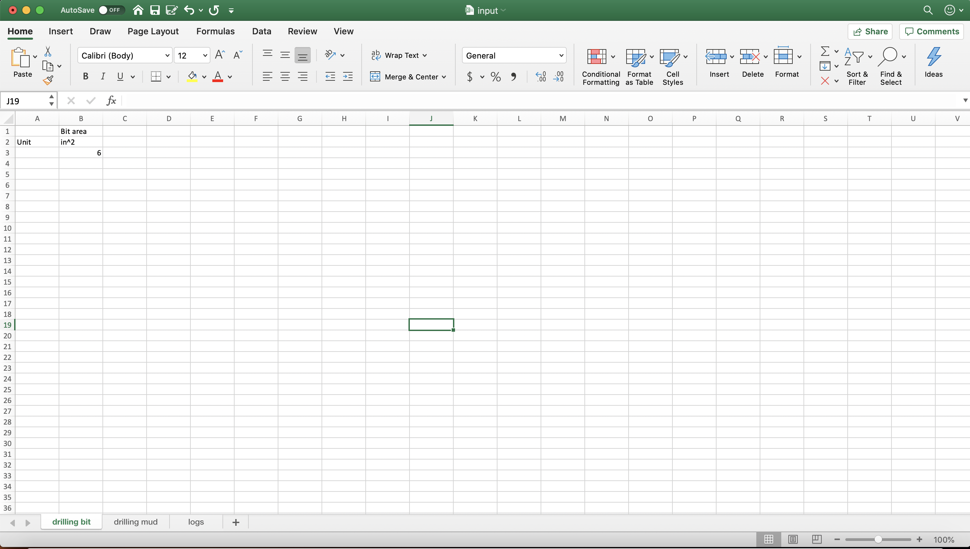

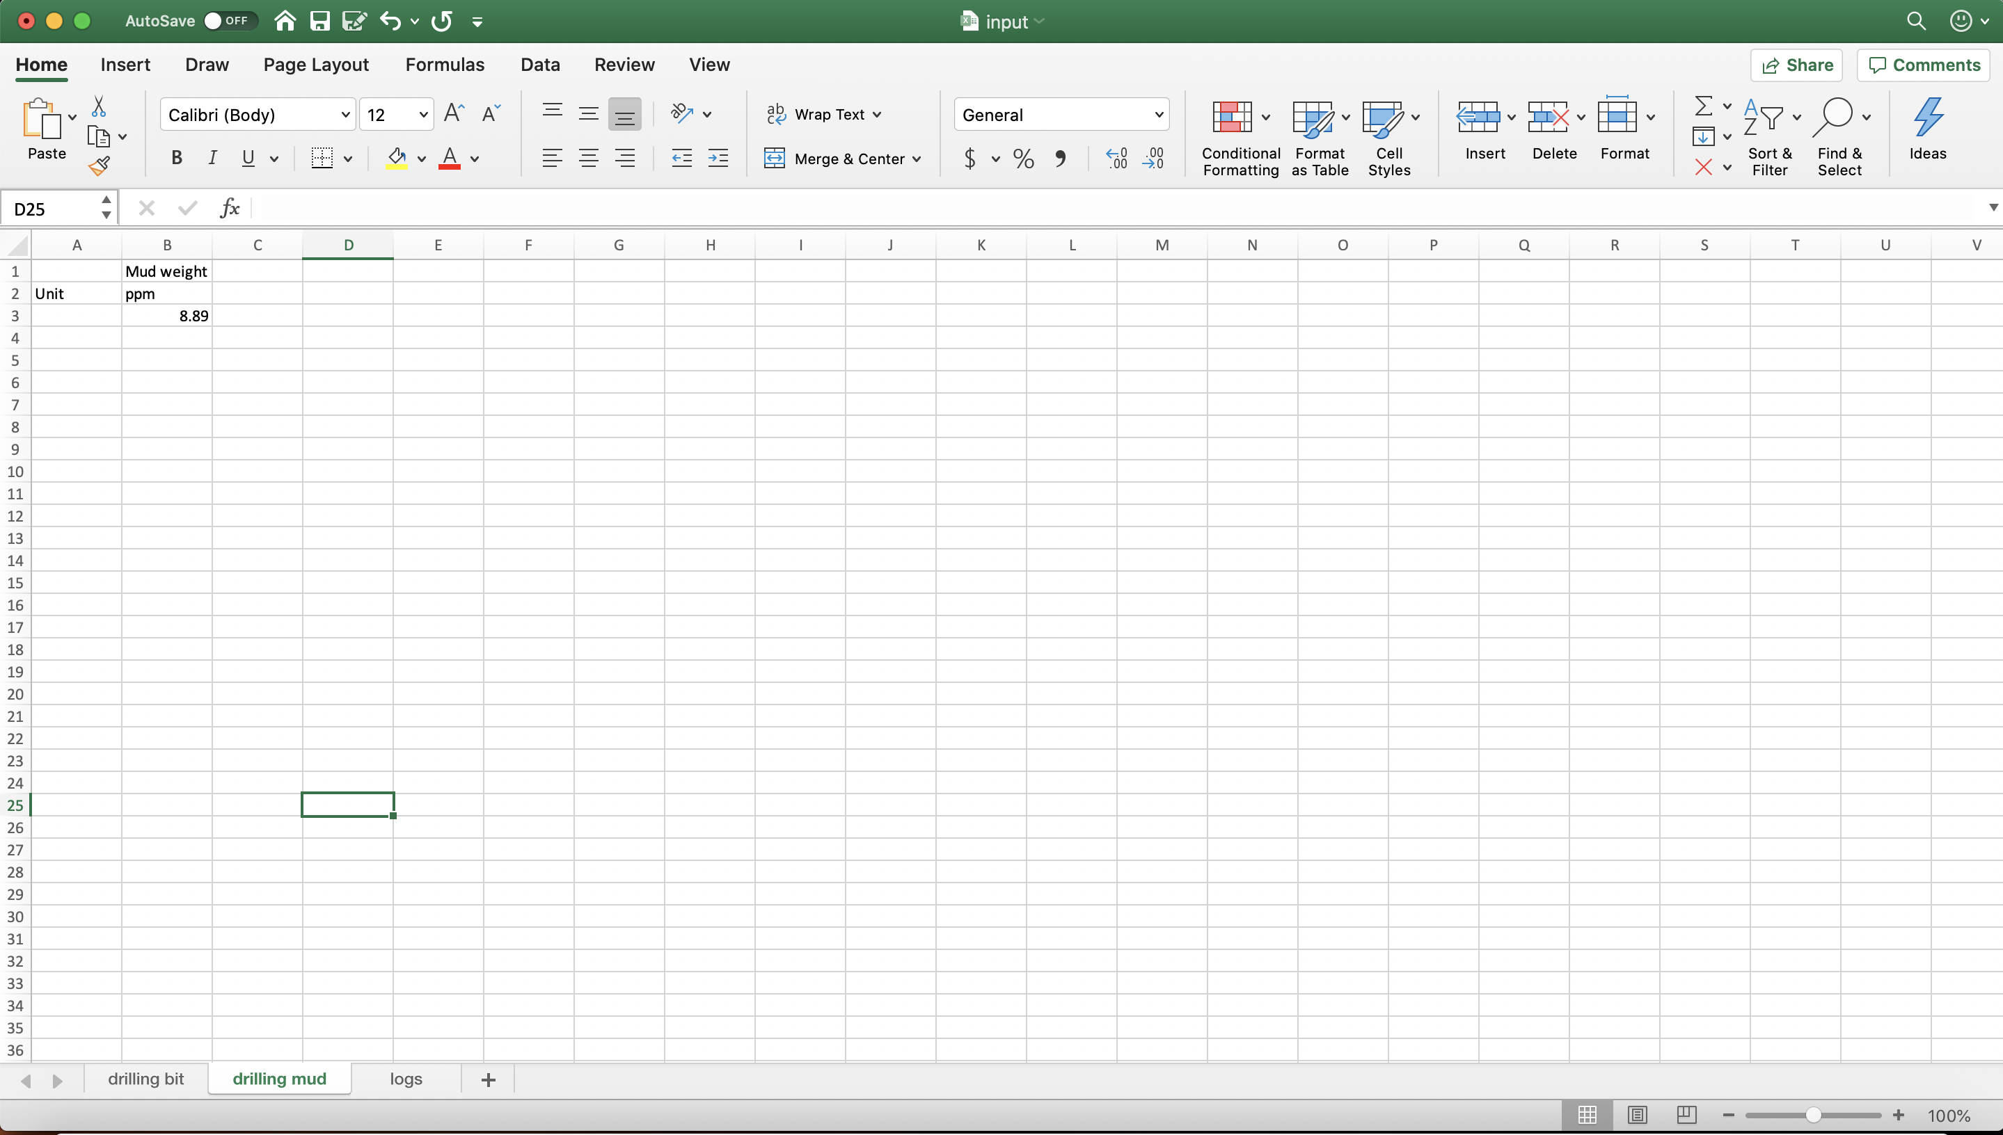

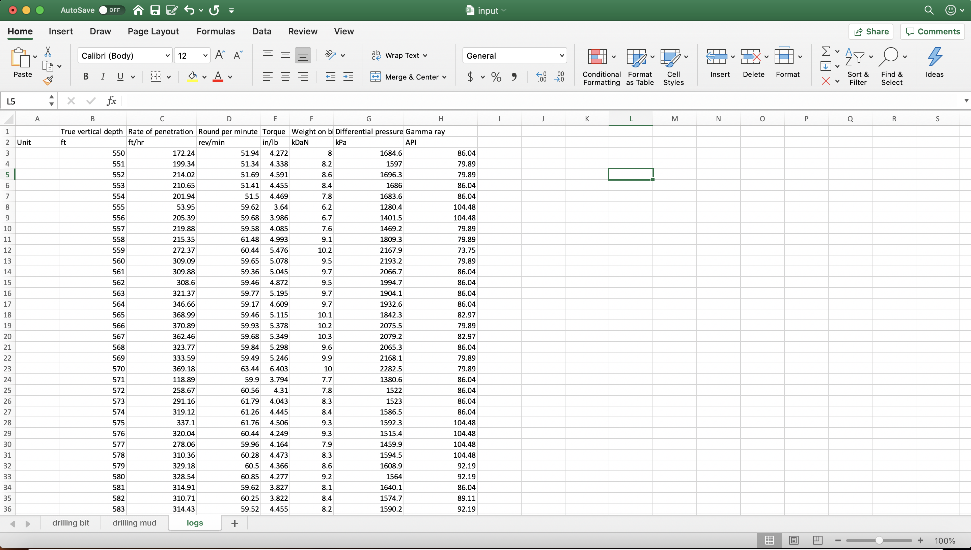

1. Save this excel file to the folder named input. Name it whatever you want.

For this demonstration, I name the input file “input”. If you do the same, when you open the input folder, it should have an excel name “input”, like this:

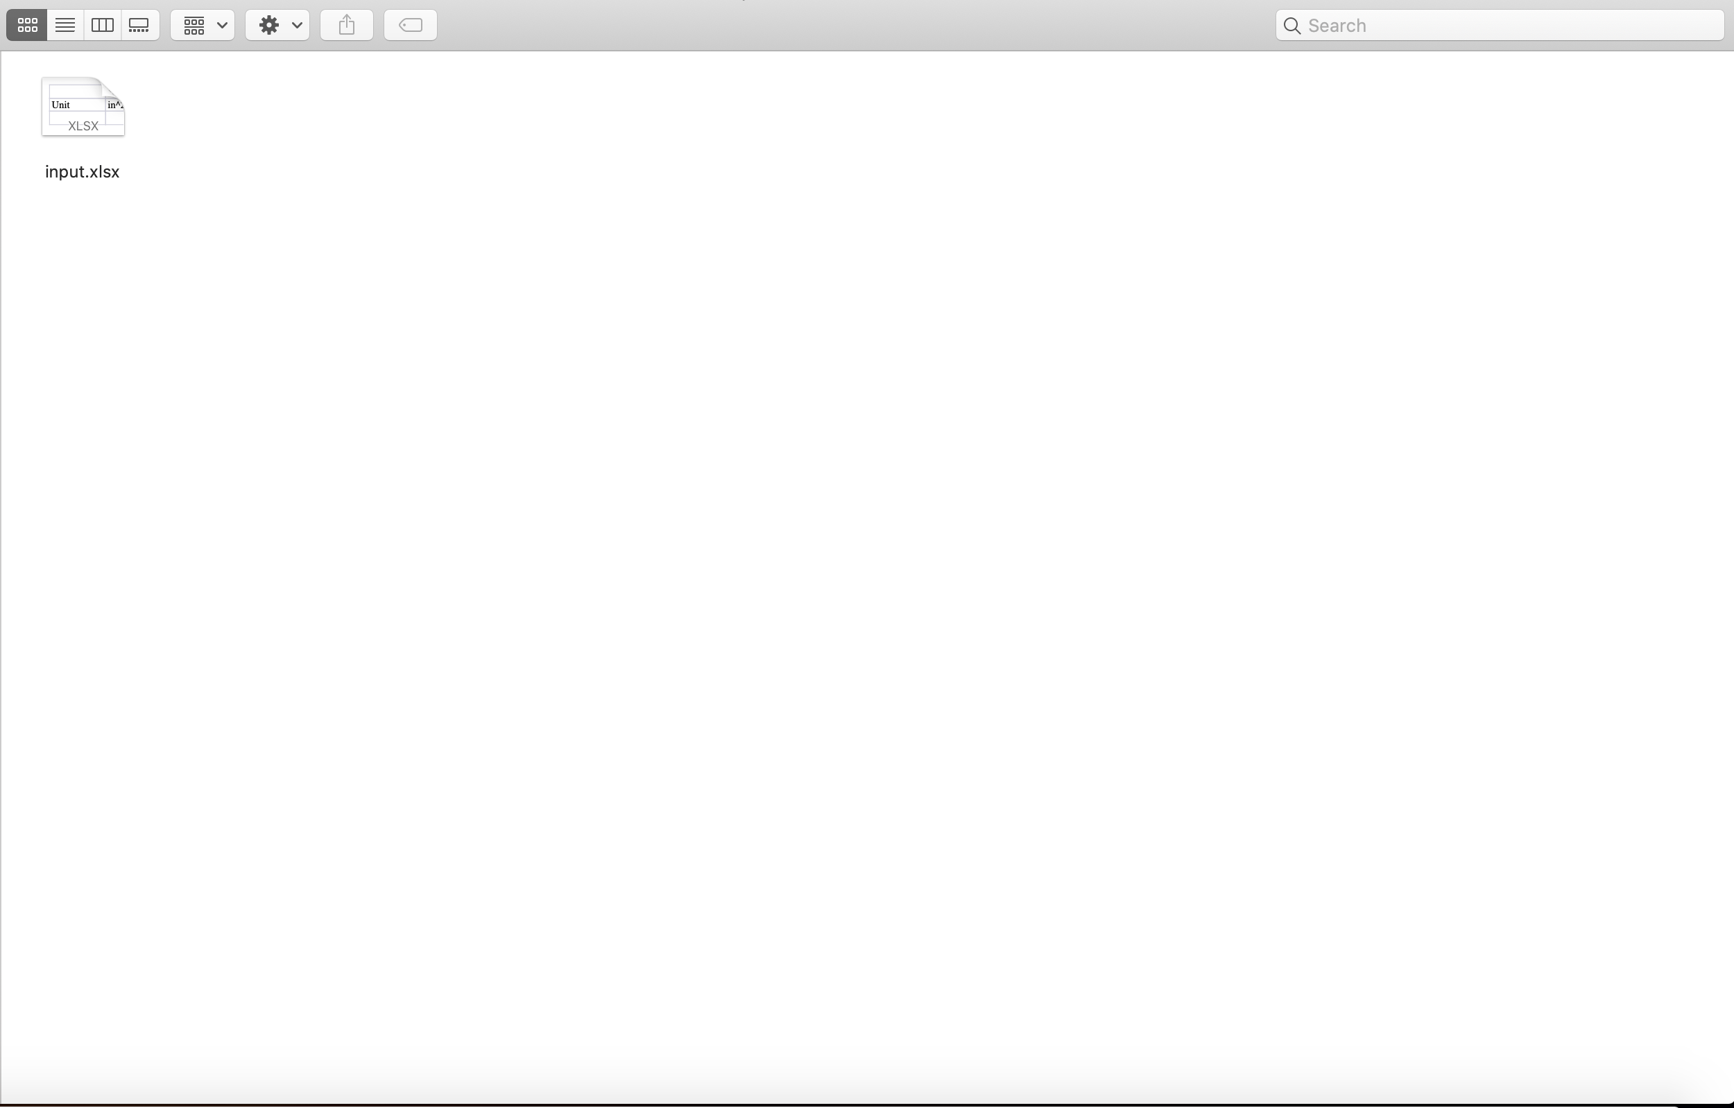

You will do this input procedure again every time you want to run any analysis on any well.

The next step is to run the calculation. Please open the anaconda window again. You have already done already.



1. Left-click on the first box on the right side.

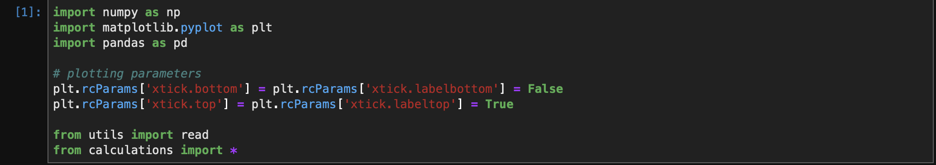

This is called a shell. It contains code to run other codes. To execute the shell, hold Shift-Enter.

1. Locate the input excel file. This is done through file_location

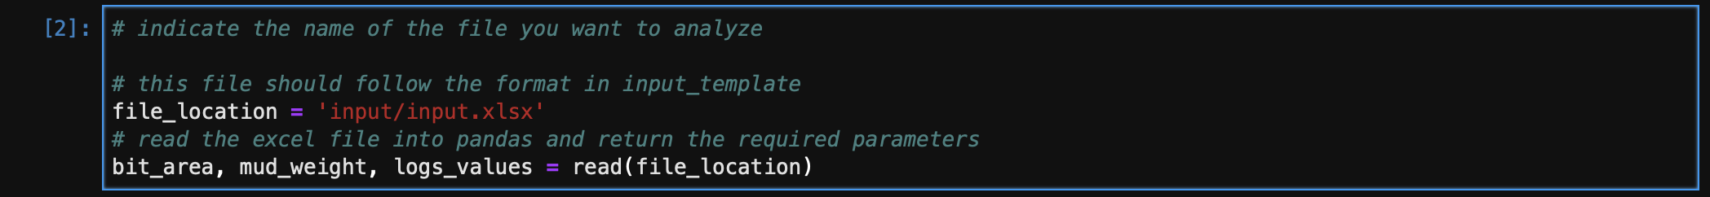

If you save the data as input in the input folder, you don’t need to change anything. But if you save the excel as file2, it must be

file_location = ‘input/file2.xlsx’

Make sure you hit Shift-Enter.

1. Extract logs values from your input into Anaconda shell.

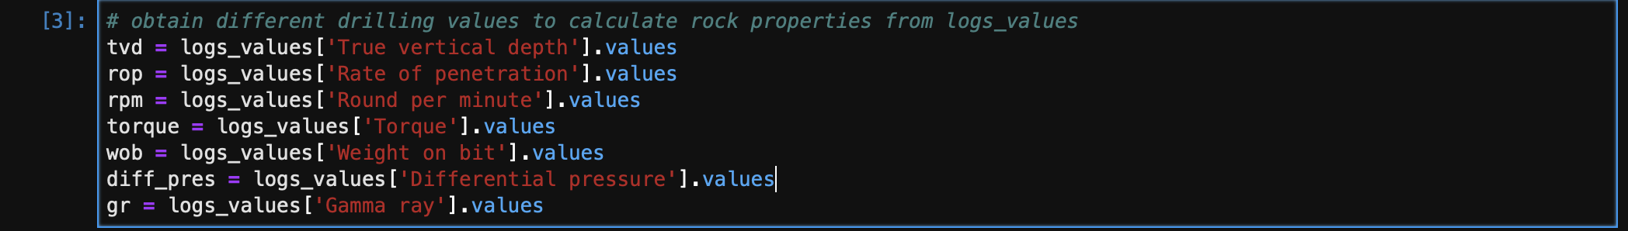

There’s not much for you to modify here. You just extract data from excel into Anaconda.

Don’t forget to Shift-Enter to proceed.

1. Calculate hydrostatic pressure and confining pressure

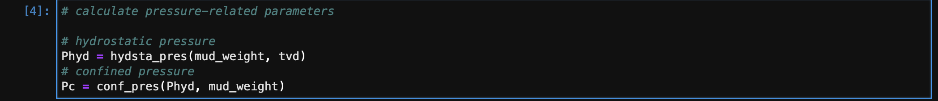

This step is dependent on mud weight. This is the mud weight you input into your excel input file above.

Shift-enter to proceed.

1. Calculate rock properties.

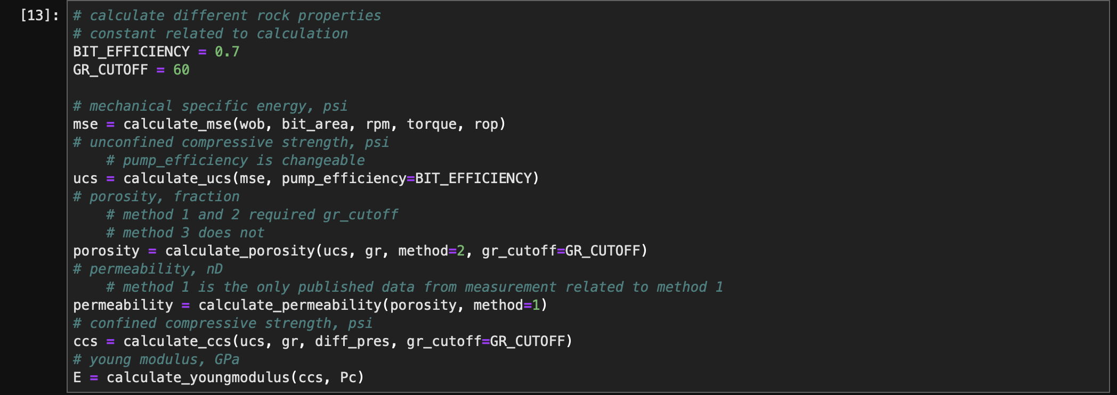

There are a few parameters you can change here:

* BIT_EFFICIENCY: this is how much the bit performs overall. It takes any value from 0 to 1 in fractional form. This parameter controls the UCS calculation.
* GR_CUTOFF: this is the boundary between sand and shale. I believe it is somewhere between 60 and 80. This is required for porosity method 1 and 2. For porosity method 3, this doesn’t matter.

For MSE:

* It takes 5 drilling parameters that you already defined above on step 3.

For UCS:

* It is dependent on bit efficiency. If you want to try a different BIT_EFFICIENCY, say 0.5, you will need to set BIT_EFFICIENCY = 0.5

For porosity

* There are 3 methods to calculate (1, 2, and 3). Method 1 and 2 required gr_cutoff, which is set to GR_CUTOFF. If you want to try a different GR_CUTOFF, you will set GR_CUTOFF to that new value. Method 3 doesn’t required GR_CUTOFF, so if method=3, the value you feed to GR_CUTOFF doesn’t matter.
* Method 1 is basically a curve fitting to different rock types, that’s why they require gamma ray cutoff to tell what kind of rock the equation fits to: <http://www.rocsoltech.com/wp-content/uploads/2018/09/Evaluating-Multiple-Methods-to-Determine-Porosity-from-Drilling-Data-AC-SPE-185115-MS-1.pdf>
* Method 2 reference (same idea as of method 1): <http://www.rocsoltech.com/wp-content/uploads/2018/09/An-Empirical-Model-to-Estimate-a-Critical-Stimulation-Design-Parameter-Using-Drilling-Data-SPE-185741-MS.pdf>
* Method 3 curve fit across different range of gamma ray, so it doesn’t require gamma ray cutoff (the reference is the same as method 2)

Click Shift-Enter to execute this shell. Note again that every time you make a change, you must Shift-Enter for it to takes effect.

1. Plot the result after you modify the method above.

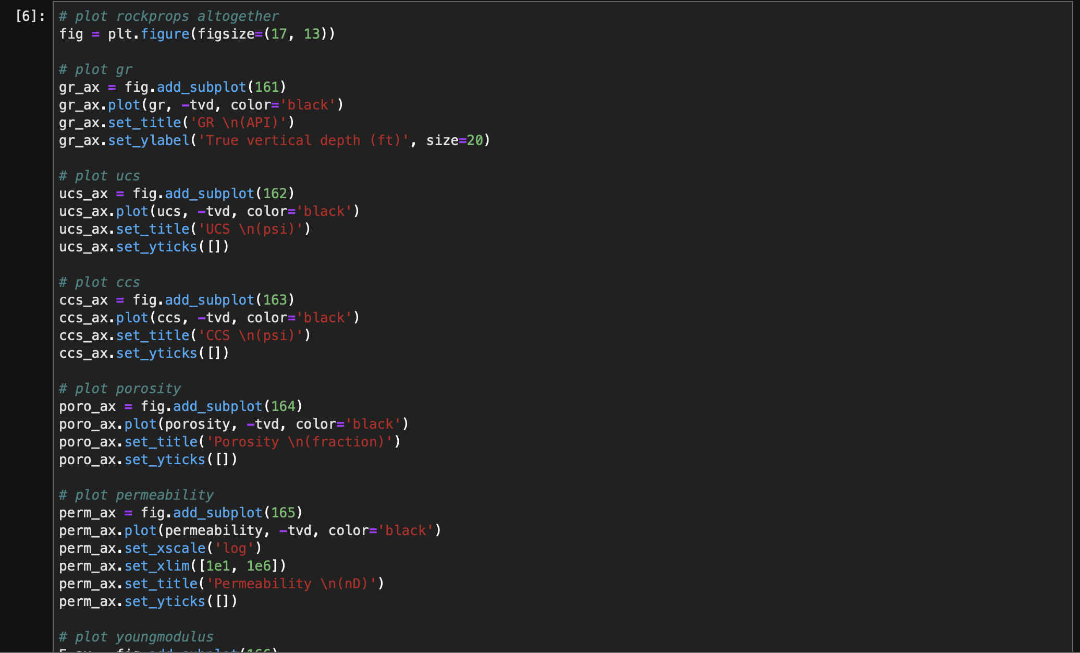

You can change how big the whole graph should the parameter figsize of

fig = plt.figure(figsize=(17,13)). Just hit Shift-Enter to see the result.

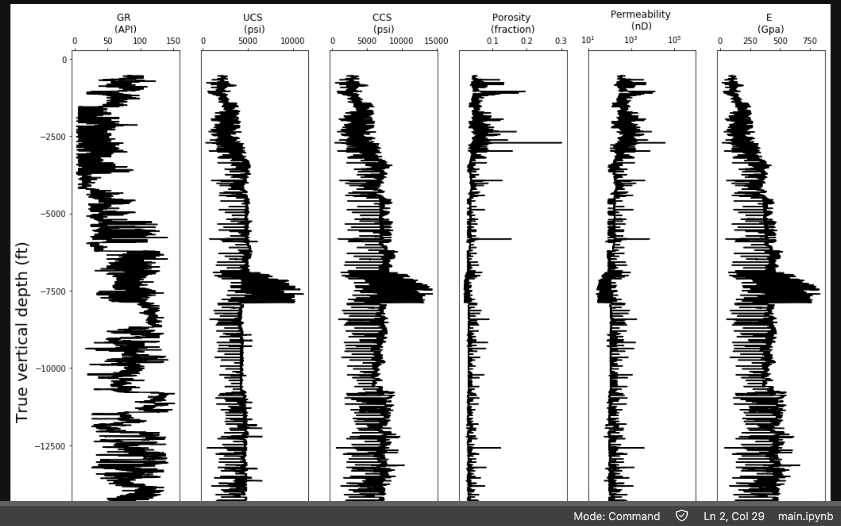

You can change the size of the figure. For instance, if you want to make it wider, try figsize=(20, 13); if you want to make it longer, try figsize=(17, 15).

For each of the plot, say gr (Gamma ray), you can modify the color. For now all colors are black. If you want separate plot to have different color, the list of colors is:

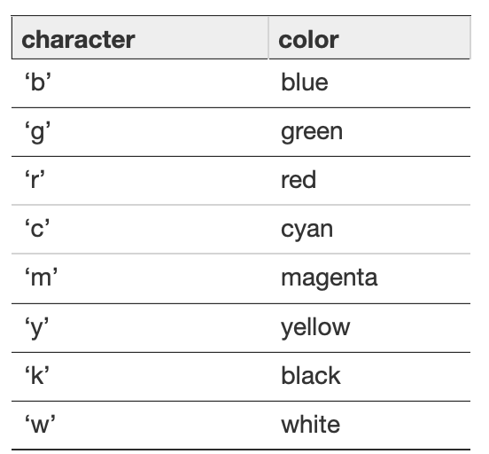

1. Save the figure



Here you will specify where to input the image. The current approach puts the image name output.pdf to the folder output.

If you want a different format, say png or jpeg, you can try:

fig.savefig(‘output/output.png’)

1. Save the calculations to an excel file

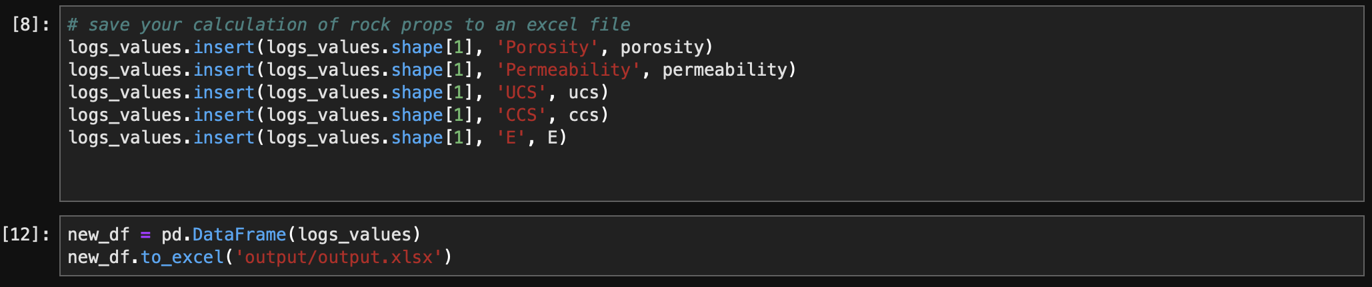

Here, it outputs the file in output folder, under the name output.xlsx. If you want to save the excel file under a different name, say output2, it should look like this:

new_df.to_excel(‘output/output2.xlsx’)

Now open the output folder, it should have two files.

